MINI-PROJECT REPORT



**AUTHENTISIGN**

**SIGNATURE VERIFICATION SYSTEM**

Submitted by: **B AMALA FRANCIS LMC23MCA-2019**

DEPARTMENT OF COMPUTER APPLICATIONS

(Affiliated to APJ Abdul Kalam Technological University, Kerala (KTU))

**LOURDES MATHA COLLEGE OF SCIENCE AND TECHNOLOGY KUTTICHAL, THIRUVANANTHAPURAM-695574**

**AUTHENTISIGN**

**SIGNATURE VERIFICATION SYSTEM**

### A Project Report

***Submitted By:***

## B AMALA FRANCIS - LMC23MCA-2019

*in partial fulfillment of the requirements for the award of the degree in*

## MASTER OF COMPUTER APPLICATIONS

*at*



## DEPARTMENT OF COMPUTER APPLICATIONS LOURDES MATHA COLLEGE OF SCIENCE AND TECHNOLOGY

**KUTTICHAL, THIRUVANANTHAPURAM-695574**

**(AFFILIATED TO APJ ABDUL KALAM TECHNOLOGICAL UNIVERSITY, KERALA)**

### NOVEMBER 2024

**LOURDES MATHA COLLEGE OF SCIENCE AND TECHNOLOGY KUTTICHAL, THIRUVANANTHAPURAM – 695574**

**(Affiliated to APJ Abdul Kalam Technological University, Kerala)**

### DEPARTMENT OF COMPUTER APPLICATIONS



**CERTIFICATE**

This is to certify that the project work entitled **“AUTHENTISIGN – SIGNATURE VERIFICATION SYSTEM USING CNN”** is a Bonafide record of the work done by **Ms. B AMALA FRANCIS**, Reg No **LMC23MCA-2019**, student of Department of Computer Applications, Lourdes Matha College Of Science And Technology, Kuttichal, Thiruvananthapuram, affiliated to the APJ Abdul Kalam Technological University, Kerala from August 2024 to November 2024 in partial fulfillment of the requirements for the award of the Degree of Master of Computer Applications from APJ Abdul Kalam Technological University, Kerala.

**Prof. RAMYA KRISHNAN S Date:**

**(Internal Guide)**

**Prof. Bismi K Charleys**

**(Head of the Department)**

### DECLARATION

I undersigned here by declared that the project report **“AUTHENTISIGN -SIGNATURE VERIFICATION SYSTEM USING CNN”** submitted for partial fulfilment

of the requirements for the award of degree of Master of Computer Applications of the APJ Abdul Kalam Technological University, Kerala. This submission represents my idea in my own words and, I have adequately and accurately cited and referenced the original sources. I also declare that I have adhered to ethics of academic honesty and integrity and have not misrepresented or fabricated any data or idea or fact of source in my submission. I understand that any violation of the above will be a cause for disciplinary action by the institute and/or the University.

Place: TRIVANDRUM B AMALA FRANCIS

Date:

### ACKNOWLEDGEMENT

An endeavour over a long time can be successful only with advice and support of many well-wishers. I wish to place on record my profound indebtedness and gratitude to all those who have contributed directly or indirectly to make this project work a success.

At the very onset, I express my gratitude to god Almighty who sheltered me under his protective wings and showered on innumerable blessings throughout the period of this Master of Computer Application.

It is a great pleasure to express my sincere gratitude to **Rev.Fr. Bejoy Arackal**, Directorand **Dr. Beshiba Wilson**, Principal of Lourdes Matha College Of Science and Technology for permitting to do this project with the fullest spirit.

I am highly obliged to **Prof. Bismi K Charleys**, Head of the Department of Computer Applications of Lourdes Matha College Of Science and Technology, for being the source of inspiration throughout the course and for her valuable guidance.

With heart full of thanks, I would like to take up this opportunity to wish my Internal guide **Prof. Sherin Joseph**, Assistant Professor and all Staffs of Department of Computer Applications for their endless support, encouragements and suggestions in various stages of the development of this project. With immense love and gratitude, I thank every unknown number of numerous amounts of open- source communities for all the selfless works and contributions they’ve made. Without them and their help, I wouldn’t have made it here. Finally, I wish to express my sincere gratitude to all our friends who directly or indirectly contributed in this venture.

CONTENTS

Content Page No

ABSTRACT 1

CHAPTER 1

1. INTRODUCTION **2**
   1. General Introduction 3
   2. Goal of the Project 3

CHAPTER 2 5

1. LITERATURE SURVEY 5
   1. Study of Similar Work 5
      1. Existing System 5
      2. Drawbacks of Existing System 5

CHAPTER 3

1. OVERALL DESCRIPTION 6
   1. Proposed System 7
   2. Features of Proposed System 7
   3. Functions of Proposed System 8
   4. Feasibility Analysis 9
      1. Technical Feasibility 9
      2. Operational Feasibility 10
      3. Economical Feasibility 10
      4. Behavioural Feasibility 10

CHAPTER 4

1. OPERATING ENVIRONMENT **11**
   1. Hardware Requirements 12
   2. Software Requirements 12
   3. Tools and Platforms 12

CHAPTER 5

1. DESIGN 14
   1. System Design 15
   2. Data Flow Diagram 16
   3. Input Design 17
   4. Output Design 18
   5. Program Design 19

CHAPTER 6

1. FUNCTIONAL AND NON-FUNCTIONAL REQUIREMENTS **20**
   1. Functional Requirements 21
   2. Non-Functional Requirements 21

CHAPTER 7

1. TESTING **22**
   1. System Testing 23
   2. Unit Testing 23
   3. Integration Testing 23
   4. Black Box Testing 23
   5. Validation Testing 23
   6. Output Testing 24
   7. User Acceptance Testing 24
   8. White Box Testing 24

CHAPTER 8

1. RESULTS AND DISCUSSION **25**
   1. Results 26
   2. Screenshots 26

CHAPTER 9

1. CONCLUSION **27**
   1. System Implementation 28
   2. Future Enhancement 28
   3. Conclusion 30

CHAPTER 10

1. BIBLIOGRAPHY **31**
   1. Journals and Publications 32
   2. Websites 32

CHAPTER 11

1. APPENDICES **33**
   1. Dataset Details  34
   2. Project Git Repository 35
   3. Model Accuracy and Loss 36

# Abstract

In the digital era, where online transactions and electronic documentation dominate, ensuring the authenticity of signed documents is critical for maintaining security and trust. Signature verification plays a pivotal role in authentication by comparing a given signature against a stored reference. However, traditional approaches such as Template Matching and Dynamic Time Warping (DTW) often face challenges in handling handwriting variations and sophisticated forgeries, limiting their reliability for high-security applications.

This project leverages the capabilities of Convolutional Neural Networks (CNNs) to develop a robust offline signature verification system. CNNs, with their ability to automatically learn hierarchical features from images, provide a powerful solution for analyzing intricate patterns and subtle variations in signatures. By training the CNN on a diverse dataset of signature images, the system effectively distinguishes genuine signatures from forgeries.

The proposed solution focuses on achieving high verification accuracy, handling handwriting variations, and detecting advanced forgery attempts, making it well-suited for real-world applications in banking, legal, and security domains. By advancing biometric authentication through the integration of deep learning techniques, this project offers a reliable and efficient tool to enhance the integrity of signed documents and address modern authentication challenges.

## CHAPTER 1

**INTRODUCTION**

### GENERAL INTRODUCTION

In the digital age, where online transactions and electronic documentation are ubiquitous, the need for reliable and efficient authentication mechanisms has become increasingly critical. One of the fundamental aspects of authentication is signature verification, a process that ensures the authenticity of signed documents by comparing a given signature with a stored reference. This verification is crucial in various high-stakes domains, including banking, legal affairs, and security.

Traditionally, signature verification has relied on direct comparison techniques, such as Template Matching and Dynamic Time Warping (DTW). These methods involve comparing the geometric and temporal features of signatures to determine their similarity. While effective in some cases, these traditional approaches can struggle with variations in handwriting and sophisticated forgeries. As a result, they may not offer the robustness required for high-security applications.

The advent of machine learning has introduced new possibilities for enhancing signature verification systems. Among these, Convolutional Neural Networks (CNNs) have emerged as a powerful tool for image analysis. CNNs are designed to automatically learn and extract hierarchical features from images, making them particularly well-suited for tasks involving visual patterns and nuances. By leveraging CNNs, it is possible to develop a signature verification system that not only captures intricate details but also adapts to variations in signature styles and attempts at forgery.

### GOAL OF THE PROJECT

The goal of this project is to develop a highly accurate and robust signature verification system using Convolutional Neural Networks (CNNs). The system aims to effectively distinguish between genuine and forged signatures by leveraging advanced deep learning techniques. Key objectives include achieving high verification accuracy, handling variations in handwriting, detecting sophisticated forgeries, and ensuring efficient performance for real-world applications.

This project focuses on the development of a signature verification system that employs CNNs to achieve high accuracy and robustness in verifying offline signatures. The system utilizes a deep learning approach, where CNNs are trained on a diverse and comprehensive dataset of signature images. The architecture of the CNN includes multiple convolutional and pooling layers, which enable the model to learn complex patterns and features. These learned features are then used by fully connected layers for accurate classification of signatures as genuine or forged.

The significance of this project lies in its potential to advance biometric authentication by providing a more reliable and efficient tool for signature verification. By harnessing the power of CNNs, the project aims to enhance the security and integrity of signed documents offering a robust solution for modern authentication challenges.

## CHAPTER 2

**LITERATURE SURVEY**

### STUDY OF SIMILAR WORK

* + - Siamese Neural Networks for Signature Verification (2016): Introduced a CNN-based Siamese architecture to compare pairs of signatures by learning feature embeddings. This approach achieved significant improvements in detecting both random and skilled forgeries.
    - Offline Signature Verification Using HOG Features and SVM (2015): The authors extracted Histogram of Oriented Gradients (HOG) features from signature images and classified them using SVM. The system performed well on smaller datasets but was less robust against skilled forgeries.

### EXISTING SYSTEM

Existing signature verification systems largely depend on traditional methods like Template Matching and Dynamic Time Warping (DTW). Template Matching compares the geometric structure of a given signature with a stored reference by measuring spatial alignment and overlap. While straightforward, this method struggles with even minor variations in handwriting styles, such as changes in stroke curvature or thickness, often leading to inconsistent and unreliable results. Similarly, DTW, which is mainly used for online signatures, measures the temporal alignment of pen movements, capturing sequential data like stroke speed and pressure. However, DTW is ineffective for offline signatures, where such temporal information is unavailable.

These methods face significant limitations when dealing with intra-class variability, where genuine signatures from the same individual differ due to natural variations in handwriting. Additionally, traditional techniques are not robust enough to detect skilled or sophisticated forgeries, making them unsuitable for high-security applications such as banking or legal domains. The lack of adaptability to diverse handwriting styles and complex forgeries undermines the reliability of these systems, particularly in real-world scenarios that require high accuracy and resilience.

Manual verification, often employed alongside these techniques, involves human experts visually comparing signatures. However, this process is time-consuming and error-prone, especially when handling large volumes of signatures or complex cases. It also lacks the scalability required for modern authentication tasks. These combined challenges make it evident that traditional systems fall short in addressing contemporary needs, emphasizing the necessity for advanced, automated solutions that offer greater efficiency, accuracy, and robustness.

### DRAWBACKS OF EXISTING SYSTEM

1. **Inability to Detect Skilled Forgeries:** These methods are ineffective against sophisticated forgeries created by skilled individuals who mimic genuine signatures with high accuracy.
2. **Limited Applicability:** Techniques like Dynamic Time Warping (DTW) rely on temporal data, making them suitable only for online signatures where stroke dynamics such as speed and pressure are available. They are not applicable to offline signatures.
3. **Lack of Robustness for High-Security Applications:** Traditional systems do not provide the reliability and adaptability required in high-security domains such as banking, legal, and governmental applications.
4. **Error-Prone Manual Verification:** Manual signature verification, often used to supplement traditional methods, is time-consuming, inconsistent, and prone to human error, particularly for large-scale authentication tasks.
5. **Scalability Issues:** Traditional techniques and manual methods struggle to scale effectively for applications requiring the verification of large numbers of signatures.

These drawbacks highlight the need for advanced automated solutions leveraging machine learning or deep learning techniques to overcome the limitations of existing systems.

## CHAPTER 3

**OVERALL DESCRIPTION**

### PROPOSED SYSTEM

Our proposed system leverages Convolutional Neural Networks (CNNs) to enhance signature verification. Key features include:

* **High Accuracy**: Utilizes CNNs to automatically learn and extract detailed features from signature images, ensuring precise differentiation between genuine and forged signatures.
* **Robustness**: Effectively handles variations in handwriting styles and detects sophisticated forgeries by learning complex patterns through deep learning.
* **Efficiency**: Optimized for fast processing and scalable performance, making it suitable for real-world applications.

This advanced system provides a significant upgrade over traditional methods and basic machine learning approaches, offering a reliable and effective solution for high-stakes signature authentication.

### FEATURES OF PROPOSED SYSTEM

The proposed movie recommendation system integrates emotion detection with user preferences to offer highly personalized and dynamic suggestions. Key features include:

##### High Accuracy:

The proposed system employs Convolutional Neural Networks (CNNs) to automatically learn and extract intricate features from signature images. Unlike traditional methods, which rely on handcrafted features, CNNs analyze the entire image to identify subtle patterns and nuances. This deep learning approach ensures precise differentiation between genuine and forged signatures, leading to significantly higher accuracy in verification.

##### Robustness:

By leveraging the hierarchical learning capability of CNNs, the system effectively handles variations in handwriting styles, such as differences in stroke thickness, pressure, and curvature. Furthermore, the system can detect sophisticated forgeries by learning complex and abstract patterns, making it highly reliable for applications requiring high security.

##### Efficiency:

The system is optimized for fast processing, enabling quick verification of signatures. It is designed

to scale effectively, making it suitable for real-world applications with high-volume requirements, such as banking, legal, or government sectors. Its efficiency ensures that it can handle large datasets and diverse signature styles without compromising performance.

##### Advanced over Traditional Systems:

Compared to traditional methods and basic machine learning techniques, this system provides a significant technological upgrade. It eliminates the reliance on manual verification and handcrafted feature engineering, offering a fully automated, reliable, and modern solution for signature authentication.

### FUNCTIONS OF PROPOSED SYSTEM

##### Image Preprocessing:

The system begins by preprocessing input signature images to ensure uniformity and enhance feature extraction. This involves resizing the images to a fixed dimension, normalizing pixel values, and applying techniques like grayscale conversion or noise reduction to improve the quality of the input data.

##### Feature Extraction:

Using Convolutional Neural Networks (CNNs), the system automatically extracts relevant features from the signature images. The CNN identifies patterns such as edges, curves, textures, and other visual details that distinguish genuine signatures from forged ones. This hierarchical feature extraction ensures that both low-level (basic shapes) and high-level (complex patterns) features are captured.

##### Signature Comparison:

The system compares the extracted features of the input signature against the stored reference signature. Through deep learning, the model calculates the similarity between the two sets of features, enabling it to classify the signature as genuine or forged with high precision.

##### Forgery Detection:

By learning intricate and abstract patterns during training, the system can identify sophisticated forgeries, including those created by skilled individuals. It uses the unique ability of CNNs to recognize even minute discrepancies that traditional methods often fail to detect.

1. **Real-Time Processing:**

The system is optimized for fast processing, enabling it to verify signatures in real time. This functionality is particularly valuable in high-volume or time-sensitive applications like banking

transactions or legal documentation.

##### Scalability and Adaptability:

The system can handle a large number of signature samples efficiently, making it scalable for enterprise-level applications. Additionally, its deep learning model adapts to diverse datasets, allowing it to perform consistently across different handwriting styles and signature formats.

### FEASIBILITY ANALYSIS

Feasibility study evaluates the proposed system's workability, impact on the organization, ability to meet user needs, and effective use of resources. Before development, a new project typically undergoes this study to determine if it will serve the organization’s goals, given the required effort, time, and resources. The feasibility study helps developers foresee the project’s future and its practical application. While all projects are technically feasible with unlimited resources and time, the development of computer-based systems often faces constraints such as limited resources and tight deadlines. Feasibility and risk analysis are interconnected, as higher project risks can decrease the likelihood of delivering high-quality software on time.

### TECHNICAL FEASIBILITY

Technical feasibility centres on existing system and to what extent it can support proposed modifications. It involves financial enhancement. This evaluation determines whether the technology needed for the proposed system is available or not. This is concerned with specifying satisfy the user requirements. The technical needs of the system may include front-end and backend-selection. An important issue for the development of a project is the selection of suitable front-end and backend. Based on some aspects, we select the most suitable platform that suits the needs of the organization.

### OPERATIONAL FEASIBILITY

The present system is easily understandable. The users are presented with friendly user interface that helps them to understand the flow of the system more easily. Maximum transparency has been provided. The new system is very much user friendly and operational cost is bearable. The maintenance and working of the new system needs less human efforts. The proposed project is beneficial to the organization.

### ECONOMICAL FEASIBILITY

Economic feasibility is used to determine the benefits and savings expected from the Candidate system and to compare them with costs incurred. If benefits outweigh cost, then decision will be to design and implement system. Otherwise, alterations will have to be made to the proposed system. The proposed system is economically feasible.

### BEHAVIOURAL FEASIBILITY

The behavioral feasibility of the system is highly positive. Users are expected to embrace the system due to its convenience, offering real-time movie recommendations based on mood and preferences. The system’s ability to provide personalized suggestions and adapt to user emotions aligns with modern expectations for dynamic, user-centric technology. Users are likely to prefer this system over traditional static recommendation systems, which may not account for their current emotional state. Additionally, the user-friendly interface and seamless experience make the system easy for users to interact with, ensuring it is behaviorally feasible and well-received by all stakeholders

## CHAPTER 4

**OPERATING ENVIRONMENT**

### Hardware Requirements

* Processor : Intel (R) Core i3
* Speed : 2.4 Ghz
* RAM : 8GB
* Hard Disk : 200 GB
* Key Board : Standard Windows Keyboard
* Mouse : Two or Three Button Mouse
* Monitor : SVGA

### Software Requirements

* Operating System : Windows 10/11
* Application Server : Tomcat 8.X
* Front End : HTML, Streamlit
* Python Version : Python 3 or above

### TOOLS AND PLATFORMS

* + 1. **PYTHON**

Python is a high-level, interpreted programming language known for its simplicity and versatility. It supports multiple programming paradigms, including procedural, object-oriented, and functional programming. Python's readability and ease of learning make it a popular choice for beginners and experts alike. It is widely used in various domains such as web development, data analysis, machine learning, artificial intelligence, automation, and scientific computing. Python has a rich ecosystem of libraries, such as NumPy, pandas, matplotlib, TensorFlow, and Scikit-learn, which further enhance its capabilities in data manipulation, analysis, and modeling.

### JUPYTER NOTEBOOK

Jupyter Notebook is an open-source web application that allows you to create and share documents containing live code, equations, visualizations, and narrative text. It is widely used for interactive computing and data analysis. Jupyter supports many programming languages, but it is most commonly used with Python. It allows users to write and execute Python code in a step-by-step, modular way, which is particularly useful for data scientists, researchers, and educators. Jupyter Notebooks also integrate seamlessly with libraries like Matplotlib and seaborn for data visualization, making it an essential tool for data exploration and analysis. It allows easy sharing of work through interactive documents, making it an effective tool for collaboration.

### CONVOLUTIONAL NEURAL NETWORKS (CNNS)

### A **Convolutional Neural Network (CNN)** is a deep learning model commonly used for **image recognition** and **visual tasks**. CNNs automatically learn spatial hierarchies of features, making them effective for tasks like classification, detection, and segmentation.

### Key Components:

1. **Convolutional Layer**: Applies filters to the input image to extract features (e.g., edges, textures).
2. **Activation Function (ReLU)**: Introduces non-linearity by turning negative values to zero.
3. **Pooling Layer**: Reduces the spatial size of the feature maps (e.g., Max Pooling, Average Pooling).
4. **Fully Connected Layer**: Performs high-level reasoning and decision-making.
5. **Softmax Layer**: Converts output into probabilities, especially for classification tasks.

## CHAPTER 5

**DESIGN**

### 5.1 SYSTEM DESIGN

System Design involves translating system requirements and conceptual design into technical specifications and general flow of processing. After the system requirements have been identified, information has been gathered to verify the problem and after evaluating the existingsystem, a new system is proposed.

System Design is the process of planning of new system or to replace or complement an existing system. It must be thoroughly understood about the old system and determine how computers can be used to make its operations more effective.

System design sits at technical the kernel of system development. Once system requirements have been analysed and specified system design is the first of the technical activities-design, code generation and test- that required build and verifying the software. System design is the most creative and challenging phases of the system life cycle. The term design describes the final system and the process by which it is to be developed.

System design is the high-level strategy for solving the problem and building a solution. Systemdesign includes decisions about the organization of the system into subsystems, the allocation of subsystems to hardware and software components and major conceptual and policy decisionthat forms the framework for detailed design.

There are two levels of system design:

* + - Logical design.
    - Physical design.

In the logical design, the designer produces a specification of the major features of the systemwhich meets the objectives. The delivered product of logical design includes current requirements of the following system components:

* + - Input design.
    - Output design.

### 5.2 WORK FLOW DIAGRAM

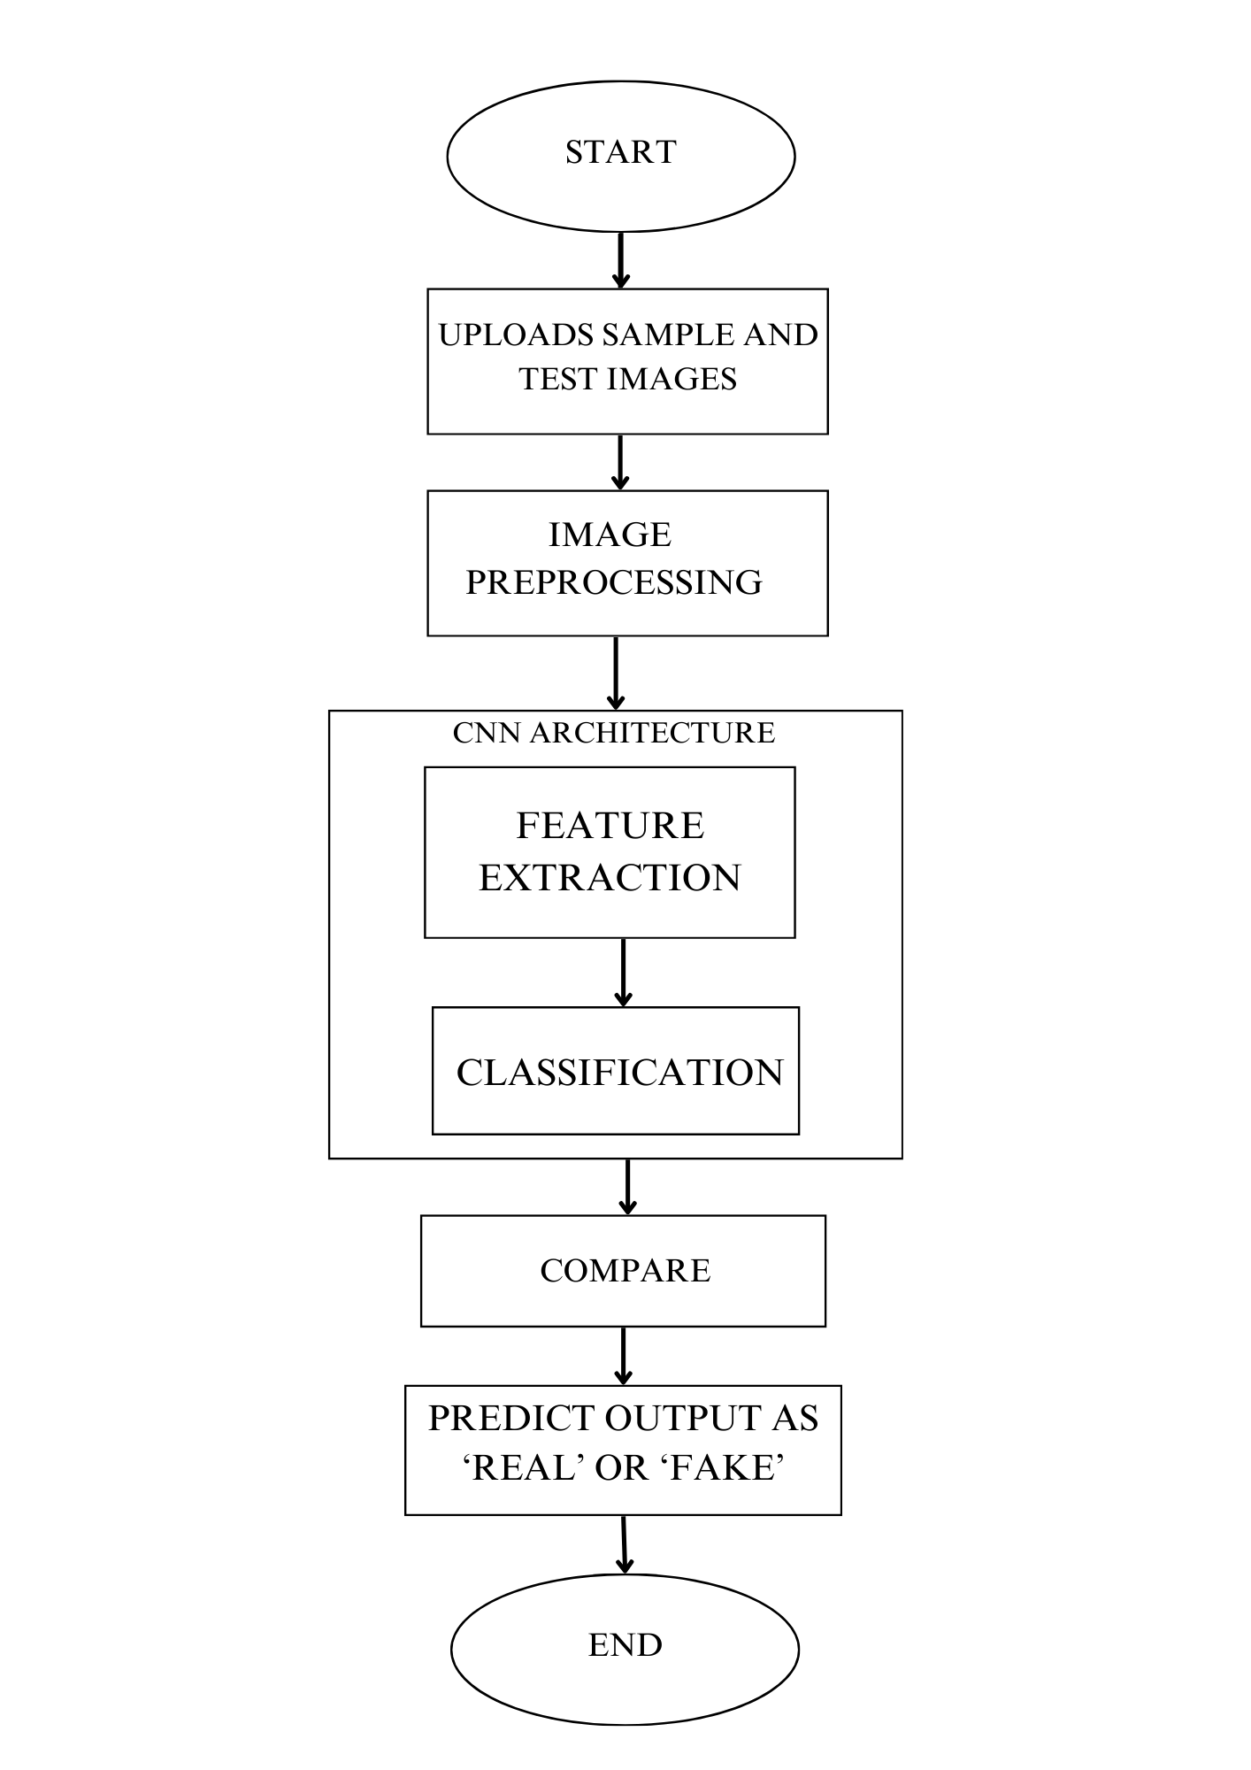

### 5.3 INPUT DESIGN

The input design of the "Signature Verification System" project focuses on the way the system receives and handles user inputs. This includes defining how users upload and interact with signature images, as well as how the data is processed before it is passed on to the machine learning models for verification.

The input design consists of user interfaces and backend processes that handle the input data. It ensures data quality, standardization, and optimal interaction between users and the system.

The following points should be considered while designing the input:

1. **User Interface (Front-End Input):**

The front-end focuses on how users interact with the system to provide necessary input for verification. Key features include:

* **Original Signature Upload:** Users can upload the reference signature image, which serves as the benchmark for verification.
* **Test Signature Upload:** Users upload the signature image that needs to be verified against the original signature.
* **Compare Button:** A simple button that initiates the verification process, passing both signature images to the backend for processing.
* **Validation and Error Handling:** The system checks that uploaded files meet required criteria, such as format (e.g., JPEG, PNG), size, and quality. If errors occur, such as uploading the wrong file type or a low-quality image, the system provides user-friendly feedback to correct the issue.

1. **Back-End Input Processing:**

The backend processes input data to prepare it for analysis and comparison by the machine learning model. Key functions include:

* **Preprocessing:**
* **Image Resizing:** Adjusts the dimensions of input images to a standard size to ensure compatibility with the machine learning model.
* **Binarization and Noise Removal:** Converts the image to a binary format (black and white) and removes any noise or artifacts that could interfere with feature extraction.
* **Normalization:** Scales pixel values to ensure consistency across all images, improving the model’s ability to learn and generalize.

* **Feature Extraction:** The system uses Convolutional Neural Networks (CNNs) or pre-trained deep learning models to extract key features from the images. Features like edges, curves, and texture are analyzed to capture the unique characteristics of the signatures.
* **Classification and Comparison:** The extracted features from the original and test signatures are compared using techniques such as Support Vector Machines (SVM) or Dynamic Time Warping (DTW). These methods help determine the level of similarity between the signatures, ultimately classifying the test signature as genuine or forged.

### 5.4 OUTPUT DESIGN

The output design of AuthentiSign is carefully structured to ensure that users receive clear and actionable information regarding the signature verification process. It emphasizes clarity, usability, and guidance to make the system intuitive and effective for users.

1. **Verification Result:**

The primary output of the system is the verification result, which determines whether the uploaded test signature matches the original signature.

* The result is displayed prominently on the user interface, labeled as either **"Real"** or **"Fake"** based on the verification.

2. **User Feedback and Guidance:**

To provide a seamless user experience, the system offers context-specific feedback and next steps:

* For a genuine signature, messages like:
  + **"Signature is verified successfully. Proceed with document approval."**
* For a forged signature, warnings such as:
* **"Signature is fake. Please recheck the document or contact the concerned authority."**

3. **Error Messages:**

When issues arise during the input process, the system generates descriptive error messages to help users resolve them:

* For invalid file formats:
  + **"Invalid file format. Please upload a JPEG or PNG image."**
* For poor image quality or incorrect dimensions:
  + **"Uploaded image is too small or low quality. Please upload a clearer image."**

These error messages ensure smooth operation and help users correct mistakes promptly.

The output design prioritizes user experience by presenting results clearly, providing optional insights, offering actionable guidance, and addressing errors effectively. This approach ensures that the system delivers value to users while maintaining high usability and reliability.

### 5.5 PROGRAM DESIGN

##### Module Breakdown:

1. **User Interface Module:**

* Enables users to interact with the system.
* Upload original and test signature images.
* "Compare" button to start the verification process.
* Display results like "Real" or "Fake" along with error messages.

##### User Interface Module:

* Prepares uploaded images for verification.
* Validate file type, size, and quality.
* Standardize images by resizing, removing noise, and normalizing.

##### Feature Extraction Module:

* Extracts important features from the images for comparison.
* Use CNN to identify unique patterns like edges and curves.
* Convert images into numerical feature data for analysis.

1. **Comparison and Classification Module:**

* Compares features and determines if the signature is genuine.
* Calculate similarity scores between signatures.
* Classify the test signature as "Genuine" or "Forged."

1. **Output Module:**

* Displays results and provides feedback.
* Show verification result: "Real" or "Fake."
* Generate a detailed report with similarity scores if needed.
* Provide suggestions for next steps based on the result.

This modular breakdown ensures that each component operates independently and can be updated or replaced without disrupting the entire system.

## CHAPTER 6

**FUNCTIONAL AND NON-FUNCTIONAL REQUIREMENTS**

### 6.1 FUNCTIONAL REQUIREMENTS

* + - Users can upload two signature images (original and test).
    - System validates image format, size, and quality.
    - Prepares images by resizing, cleaning, and normalizing.
    - Extracts features using CNN to identify patterns.
    - Compares the signatures and shows results ("Genuine" or "Forged").
    - Displays error messages for invalid uploads or issues.

### 6.2 NON-FUNCTIONAL REQUIREMENTS

* Results should be fast and accurate.
* Easy-to-use interface with clear feedback.
* Works well with low-quality images.
* Supports many users without delays.
* Keeps uploaded data secure.
* Simple to update and improve.

## CHAPTER 7

**TESTING**

#### SYSTEM TESTING

#### Objective: Test the entire system as a whole to ensure it meets all requirements.

#### Focus:

* + Check the complete workflow, from uploading signatures to displaying verification results.
  + Test the interaction between the user interface, backend processes, and CNN model.
* Example: Verify that users can upload images, the system processes them correctly, and results are displayed as “Genuine” or “Forged”.

#### UNIT TESTING

#### Objective: Test individual components or modules of the system in isolation.

#### Focus:

#### Test each function, such as input validation, preprocessing, CNN-based feature extraction, and classification.

#### Example: Check if the preprocessing module correctly resizes and normalizes input images.

#### INTEGRATION TESTING

#### Objective: Test how different modules interact with each other.

#### Focus:

#### Validate the data flow between the front-end, preprocessing module, CNN, and result display.

* Example: Ensure that an uploaded image is passed seamlessly from the user interface to the preprocessing module, processed by the CNN, and results are displayed correctly.

#### BLACK BOX TESTING

#### Objective: Test the system's functionality without looking at the internal code.

#### Focus:

#### Evaluate the input-output behavior.

#### Ensure the system handles both valid and invalid inputs effectively.

#### Example: Upload a valid signature image to check if the system produces the correct result, and upload an invalid file to see if an error message is displayed.

#### 7.5 VALIDATION TESTING

#### Objective: Confirm that the system meets the intended requirements and user expectations.

* Focus:
  + Validate input handling, result accuracy, and output presentation.
* Example: Test with a dataset of genuine and forged signatures to verify that the system classifies them accurately.

#### 7.6 OUTPUT TESTING

#### Objective: Ensure the output is correct, clear, and meaningful.

#### Focus:

#### Check the accuracy of verification results and the clarity of detailed reports (e.g., similarity scores).

#### Example: Verify that a similarity score of over 90% results in a “Genuine” classification, and below a threshold results in “Forged”.

#### 7.7 USER ACCEPTANCE TESTING

* Objective: Ensure the system meets user needs and is ready for deployment.
* Focus:
  + Test the system with end-users to gather feedback on its functionality and usability.
* Example: Allow users to interact with the system and confirm it is intuitive, provides accurate results, and handles errors gracefully.

**7.8 WHITE BOX TESTING**

* Objective: Test the internal workings of the system.
* Focus:
  + Check code logic, decision paths, and algorithms used in preprocessing, CNNs, and classification.
* Example: Verify that the CNN model is correctly processing image data and extracting features for accurate comparison.

## CHAPTER 8

## RESULTS AND DISCUSSION

### RESULTS

An effective signature verification system using CNN has implemented with an accuracy of 97%.

### SCREENSHOTS

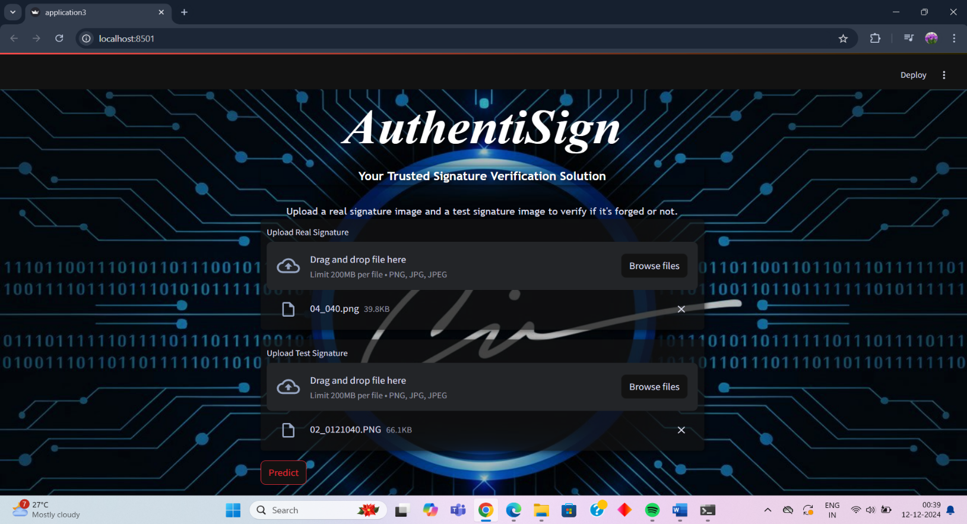

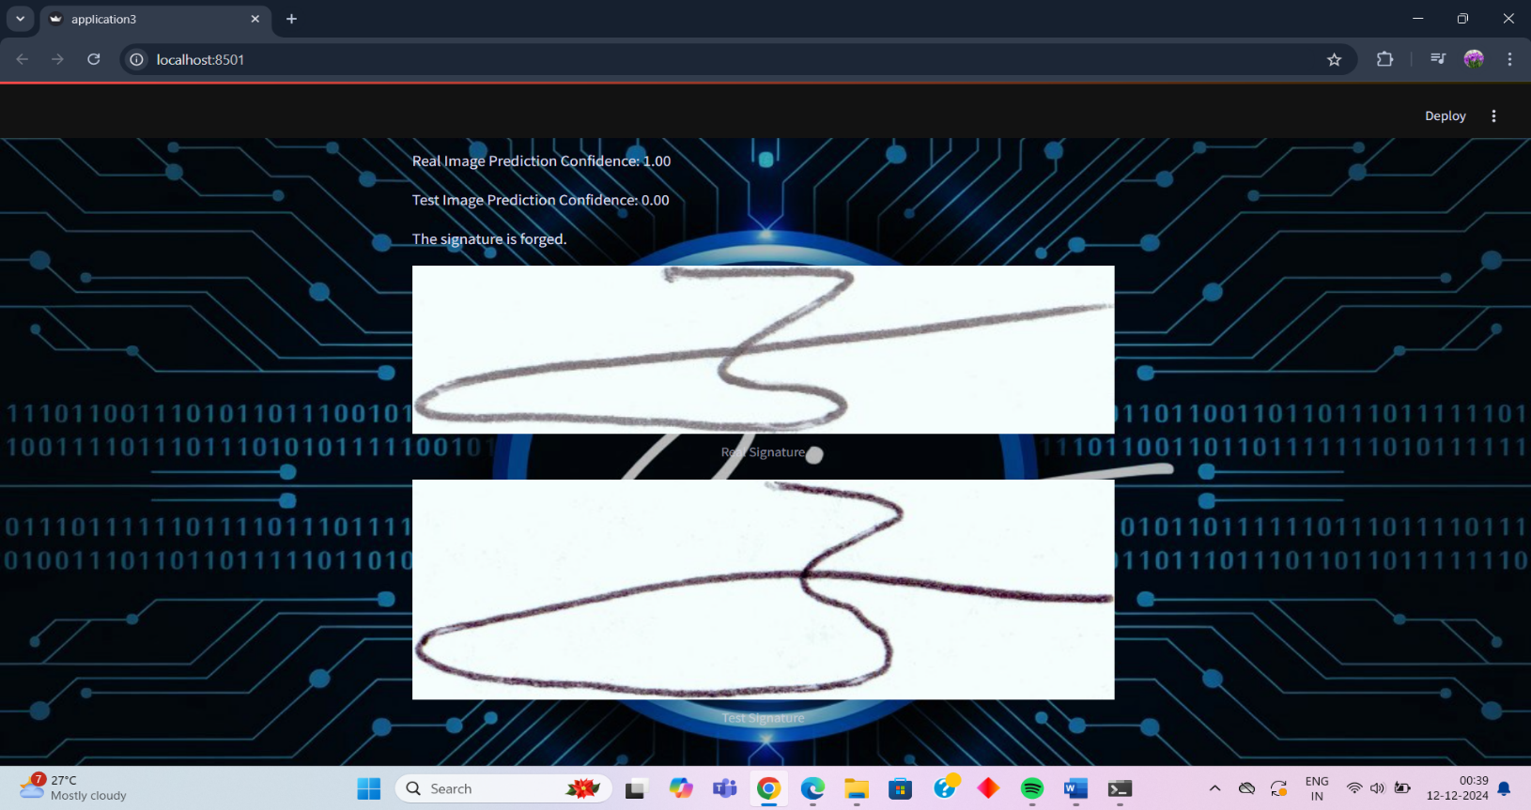

## CHAPTER 9

## CONCLUSION

### SYSTEM IMPLEMENTATION

System implementation is a critical phase in the development lifecycle where the developed system is transitioned from a theoretical design to an operational tool. It involves bringing the system into use, testing it thoroughly, and ensuring it functions efficiently and effectively for the users. A well- implemented system builds user confidence and meets the expectations set during the planning and design phases.

Implementation is the process of taking the system from its design phase to a fully functional product. The implementation plan includes an overview of the system, major tasks, resources required, and any specific site requirements. This plan is developed during the design phase and updated during development to ensure smooth execution.

There are three types of system implementations:

##### Implementation of a New Computer System to Replace a Manual System:

This type involves converting manual processes into an automated system. Common challenges include file conversion, user training, and creating accurate data files.

##### Implementation of a New System to Replace an Existing One:

Replacing an older system with a new one can be complex and may involve significant challenges. If not carefully planned, issues such as data migration, system compatibility, and user adaptation can arise, sometimes taking up to a year for full conversion in large systems.

1. **Implementation of Modified Applications on the Same Computer System:**

This type involves replacing an existing application with a modified version while using the same underlying system. It is generally easier to manage, as long as the changes to the files and architecture are minimal.

### FUTURE ENHANCEMENT

##### Real-Time Signature Verification:

The system can be upgraded to support real-time signature verification, allowing dynamic input from touchscreens or digital styluses, broadening its use cases to digital document signing and e-signature platforms.

##### Advanced Forgery Detection:

Advanced forgery detection techniques can be added by training the system on datasets with skilled forgeries, improving its ability to detect subtle or traced forgeries.

##### Cross-Platform Integration:

The system can be integrated with mobile apps, cloud services, and third-party authentication platforms, enabling cross-platform accessibility and seamless workflow integration.

##### Enhanced User Experience:

The user experience can be enhanced by incorporating features such as drag-and-drop uploads, progress bars, and voice-guided instructions for easier interaction.

##### Expanded Application Scope:

The application scope can be expanded to include identity verification, biometric authentication, and fraud detection in financial transactions, increasing the system's versatility.

##### Hybrid Deep Learning Models:

Hybrid deep learning models, combining CNNs with advanced techniques like transformers, can be implemented to achieve higher accuracy and reliability in verification.

##### Enhanced Data Security and Compliance:

Data security can be strengthened by encrypting uploads, complying with data protection laws, and ensuring secure audit trails, fostering trust and legal compliance.

##### Continuous Learning Capability:

Continuous learning capabilities can be introduced to enable the system to automatically adapt and improve with new signature data over time, maintaining its effectiveness.

1. **Multilingual Support**:

Multilingual support can be introduced to make the system accessible to users worldwide, increasing usability across various regions and demographics.

1. **Integration of Explainable AI (XAI)**:

Explainable AI (XAI) can be integrated to provide transparency by highlighting the features that influenced verification decisions, increasing user trust in the system.

### CONCLUSION

The Signature Verification System (AuthentiSign) offers a highly advanced and reliable solution for authenticating signatures, addressing the critical need for secure and efficient verification in the digital age. By utilizing Convolutional Neural Networks (CNNs), the system overcomes the limitations of traditional methods, such as their inability to handle handwriting variations and sophisticated forgeries, ensuring greater accuracy and robustness. With a user-friendly interface, streamlined input processing, and efficient backend operations, AuthentiSign provides a seamless experience for users while delivering precise results for real-world applications across banking, legal, and corporate sectors. The potential for future enhancements, including real-time verification, integration with multiple platforms, advanced forgery detection, and explainable AI, further positions this system as a cutting-edge tool in biometric authentication. By continuously adapting to emerging challenges and evolving user needs, the Signature Verification System can play a pivotal role in ensuring the security, reliability, and integrity of signed documents in a rapidly digitizing world.

## CHAPTER 10

**BIBILORAPHY**

### JOURNALS AND PUBLICATIONS

1. Signature Verification System Using CNN by S. Lakshmi Devi and Anitha.S
2. Handwritten Signature Verification Using Deep Learning by M. S. Albawi, T. A. Mohammed, and S. Al-Zawi
3. A Comprehensive Study of Signature Forgery Detection Systemsby R. Plamondon and G. Lorette
4. Comparison of Machine Learning Algorithms for Signature Verification by Y. Bengio, A. Courville, and P. Vincent

### WEBSITES

1. **Dataset** ([Signature_Verification_Dataset](https://www.kaggle.com/datasets/robinreni/signature-verification-dataset)).
2. geeksforgeeks.org
3. w3schools.com

## CHAPTER 11

**APPENDICES**

### DATASET DETAILS

**Context**

* This dataset contains the signature of dutch user both genuine and fraud.
* In the dataset the directory number says the name of the user and its classified into two : Geniune with the own user number and fraud with the user number + "_forg

**Acknowledgements**

* All the data are extracted from ICDAR 2011 Signature Dataset and organized perfectly for user usage.

** Real:**

** Forged:**

### GIT PROJECT REPOSITORY

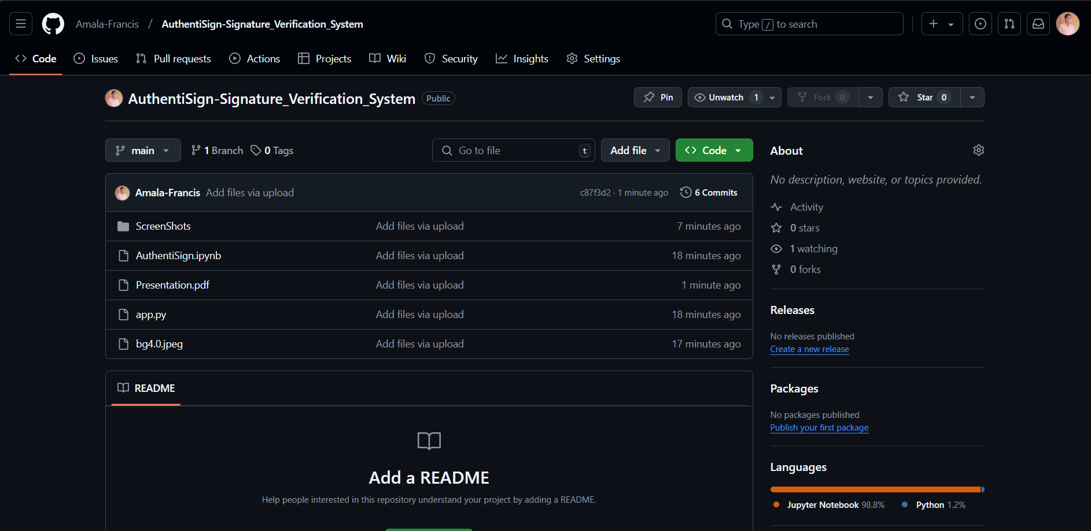

### MODEL ACURACY AND LOSS

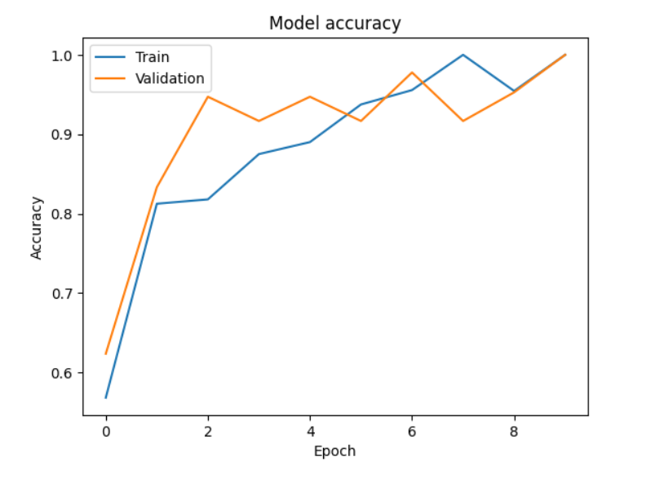

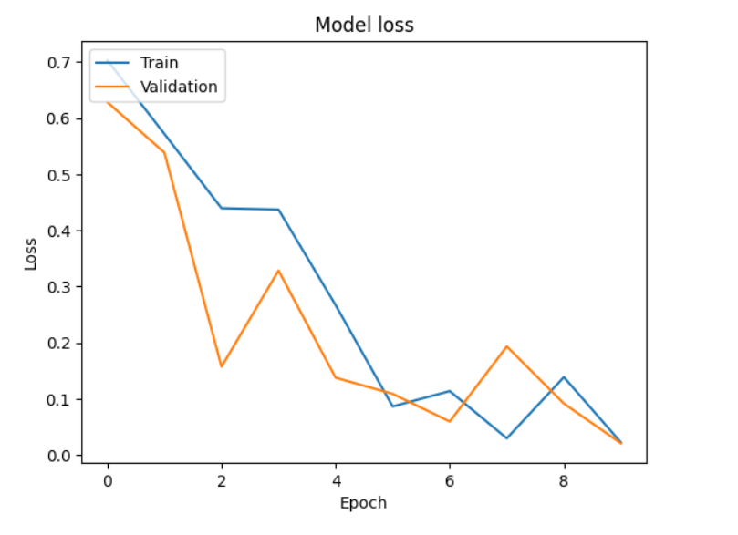

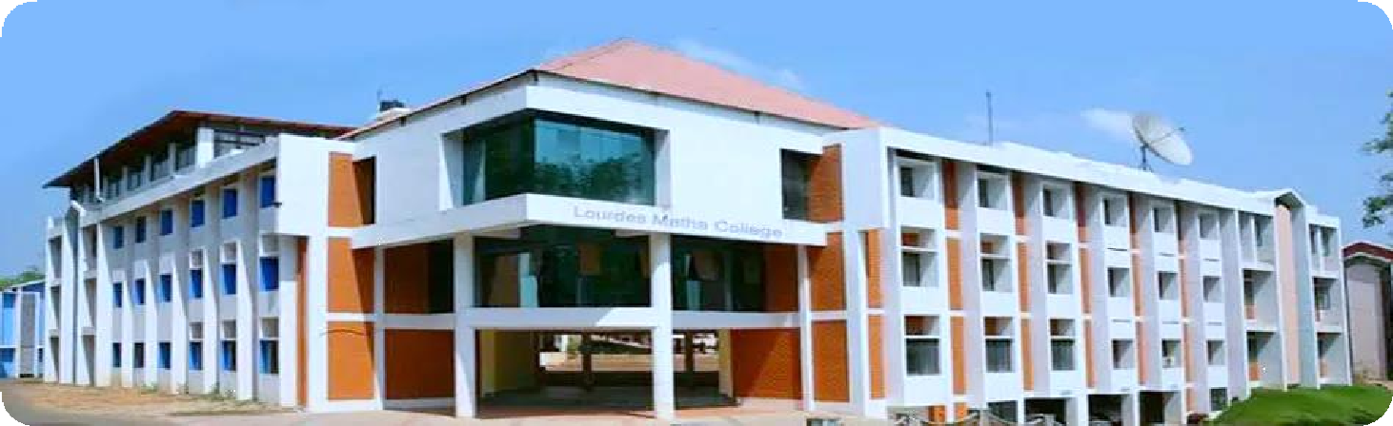

Global Fashion Network

**LOURDES MATHA COLLEGE OF SCIENCE AND TECHNOLOGY (MANAGED BY THE ARCHDIOCESE OF CHANGANASSERY) KUTTICHAL, THIRUVANANTHAPURAM-695574**

**PHONE: 0472-2853550,2853682,2853546**

**WEBSITE :** [**www.lmcst.ac.in**](http://www.lmcst.ac.in/)